# 

# **Template – Proof of High School or GED Completion Form**

The template named “Template – Proof of High School Graduation” is applicable to CampusNexus Student.

## Purpose and Outcome

This template provides a form sequence and supporting workflow for a proof of high school or GED completion form to be submitted by a student. The sequence requires the following:

* A **Student record** must exist in the CampusNexus Student database.
* The student must have a **Portal login** to log into this authenticated sequence.

Upon completion of the sequence:

* The file submitted in the form sequence is saved to the student’s Documents Center in CampusNexus Student.
* The status of the uploaded document is set to “On File” with a “Received Date” indicating the day when the upload occurred.

## Prerequisites

The template was built in Forms Builder using the applications listed below. The template is forward compatible with later versions of the listed applications.

|  |  |
| --- | --- |
| **Application** | **Minimum Version** |
| Forms Builder Designer and Renderer | 3.4 |
| Web Client for CampusNexus Student | 19.0 |
| Workflow Composer | 2.6 |
| Packages installed from Package Manager in Workflow Composer | Activities and Contracts (V1) 19.0.0  Activities and Contracts (V2) 19.0.0  Forms Builder Contracts 3.4 |
| Workflow Tracking Database | N/A |
| Staff STS 2.0 | 2.0 |

## Step 1: Download and Import the Template

1. Download the template file (xml) to your environment (local drive or network location).
2. Log into **Forms Builder Designer**.
3. Click the **Export/Import** tile.
4. Select the **Import** tab.
5. Click **Select exported file** and navigate to the downloaded template file (xml).
6. Click **Import**.

* [Export/Import](https://help.campusmanagement.com/FB/3.x/Content/ExportImport.htm)

### The following forms will be imported:

### Campus University - Proof of High School or GED Completion

### Custom – Confirmation

### WelcomeNew

## Step 2: In Form Designer…

1. From the **Forms** slide out, select the **Campus University - Proof of High School or GED Completion** form.
2. Customize the form for your environment. Modify properties on current fields to make them required, etc., or add/remove fields on form.

Make sure you edit the text in the Labels and HTML controls as applicable for your institution.

* [Fields](https://help.campusmanagement.com/FB/3.x/Content/Fields.htm) and [Components](https://help.campusmanagement.com/FB/3.x/Content/Components.htm)

1. **Save** the form.
2. Repeat steps 1-3 for the following forms:

### **Custom – Confirmation**

* **WelcomeNew**

## Step 3: In Sequence Designer…

1. Select the **Campus University - Proof of High School or GED Completion** sequence.

The sequence contains the following forms in the following order:

### WelcomeNew

### Campus University - Proof of High School or GED Completion

### Custom – Confirmation

The Custom – Confirmation form is selected as the End State Form for the sequence.

1. Click **Save As** to create a copy of the sequence/workflow and customize the copy for your use. This way you can always refer to the original sequence/workflow you downloaded.
2. Optional - Add a custom style (theme) associated with your campus.

* [Themes](https://help.campusmanagement.com/FB/3.x/Content/Themes.htm)

1. Select your sequence in the Sequences pane.
2. In the Properties Pane:
   * Ensure that the **Authentication Product** is **Student**.

* Select the **End State Form** named “Custom - Confirmation”.

1. **Save** the sequence**.**
2. Open the associated sequence workflow.

Depending on your environment, either click **Open Workflow** in Sequence Designer or launch a local installation of Workflow Composer.

* [Open the Workflows for a Sequence](https://help.campusmanagement.com/FB/3.x/Content/HostedEnv.htm)

## Step 4: In Workflow Composer…

1. Double-click the **Next** transition from the first form/state named “Welcome/New” and locate the **LookupReferenceItem** activity.

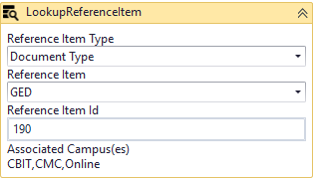

In the **Reference Item List** and **Reference Item** drop-down lists, select values that are appropriate for your environment.

* [LookuoReferenceItem activity](https://help.campusmanagement.com/WF/Content/Workflow/LookupReferenceItem.htm?Highlight=lookupreferenceitem)

1. Double-click the **Submit** transition to the End state and locate the **GetAttachments** activity.

Check the **ControlIdentifier** in the Properties of the GetAttachments activity.

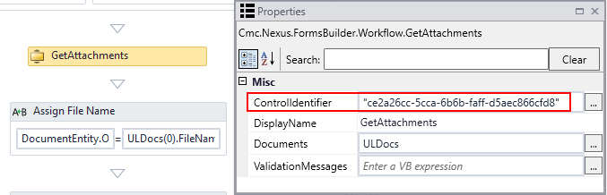

In Form Designer, confirm that the GetAttachments ControlIdentifier matches the **Id** of the **File Upload** control in the **Campus University - Proof of High School or GED Completion** form.

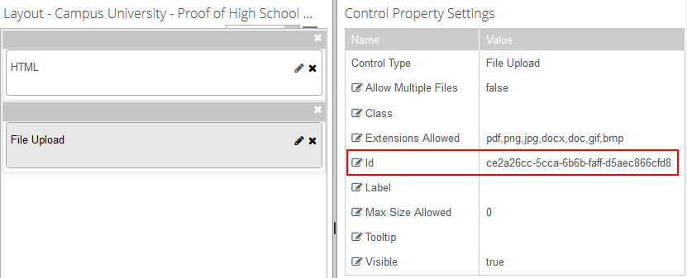

1. In the **Assign Status** activity below the GetAttachments activity, check that the **StatusId** **Value** for “Received” status is appropriate for your CampusNexus Student database.

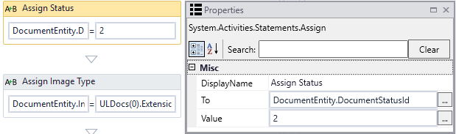:

## Step 5: In Forms Renderer and CampusNexus Student…

Select your sequence and try it out!

* [Sequence List](https://help.campusmanagement.com/FB/3.x/Content/SequenceList.htm)

1. Find your **Campus University - Proof of High School or GED Completion** sequenceand copy the **URL** to the clipboard.
2. Log in to Portal as a **student** and complete the form sequence.
3. In CampusNexus Student,
   * Verify that the document submitted as proof of high school or GED completion was added to the student’s Document Center.
   * Verify that the document’s status in the Document Center is updated to “On File” with a “Received Date” of today.

## Step 6: Lastly…

Once your updated sequence has been tested successfully, it is recommended that you disable the workflow for the original Template version.

1. In Workflow Composer, in the Server section of the ribbon, click **Open**.
2. Find the workflow named “Transcript Request Form Sequence”.
3. Clear the **Enabled** check box and click **Save**.